CENWP-OD-B
16 April 2007
MEMORANDUM FOR THE RECORD

SUBJECT: Elevated mortality at the Juvenile Monitoring Facility (JMF) on 13 April 2007.

On 13 April 2007, around 0900, PSMFC smolt monitoring personnel (Dean Ballinger) contacted Bonneville Fisheries to report an increase in mortality numbers following the release from Spring Creek National Fish Hatchery. Jon had just returned from inspecting the bypass system.

Tammy Mackey and Jon Rerecich went to the monitoring facility to find fish with evidence of hemorrhaging along the jaws, pale gills, and significant descaling. Dean indicated he didn’t think these looked like typical morts associated with the facility. Everyone agreed samples should be sent to Fish Health.

Upon returning to the office, Tammy sent the following information to several regional folks:
“From 0700 until 0900 on 13 April, SMP found about 10% of the Spring Creek fish were dead or dying. They showed signs of hemorrhaging and some had very pale gills. There was a 1.6% descaling rate. While the descaling rate doesn’t sound significant, it is considered high for Spring Creek fish.

Some of the morts and moribund fish were sent to Fish Health.

.2 million fish were coded wire tagged. It was thrown out that maybe we want to look at any impacts from the tagging.

It is only Spring Creek fish showing elevated mortality.

Dean will keep Ben and Jon apprised of any new developments over the weekend.”

Just before 1400, Tammy received a call from Margaret Filardo at the Fish Passage Center. She was requesting additional information and indicated the fish died by mechanical means, due to the split fins found, and no internal injuries or pathogens. It was noted that the halogen lights were still in place in the DSM2.

Tammy contacted RCC (Bern Klatte) to notify him of the upcoming FPAC call at 1400, where the mortality issue was to be discussed.

Around 1600, Tammy received another call from FPC. Margaret indicated they wanted to “spread the risk” so they requested a change in turbine operations. She also indicated there was increased mortality in all species. She suggested the size of Spring Creek fish may lend to their poor survival. It should be noted, however, that fry are making it through the system.

Tammy talked with Bern regarding the operational changes then notified Dean at the JMF and left a message with Ben Hausmann.

Operation changes were as follows:
XXXXXXXXXXXXXXXXXXXXXXXXXXXXXXXXXXXXXXXXXXXXXXXXXXXXXXXXXXX
BON R 041307 1730 CO BON TDA JDA MCN BPA BPC NPD NPC NPP
ATTENTION: BONNEVILLE AND BPA
REFERENCE TELETYPE BON R 041307 1212
SUBJECT: CHANGE POWER HOUSE PRIORITY AND OPERATION

TO REDUCE THE IMPACTS TO JUVENILE FISH PASSING THROUGH THE JUVENILE MONITORING FACILITY, EFFECTIVE IMMEDIATELY, OPERATE THE PROJECT IN THIS ORDER AS NEEDED WHILE SPILLING 100 KCFS (TARGET):

1. OPERATE THOSE UNITS WITHIN 1% EFFICIENCY IN BONNEVILLE POWERHOUSE TWO THAT ARE AVAILABLE AND DO NOT HAVE GAP CLOSURE DEVICES. THESE UNITS ARE 14 AND 18.
2. OPERATE UNITS IN BONNEVILLE POWERHOUSE TWO AT THE LOW END OF 1%. THESE UNITS ARE 11, 12, 13 16, AND 17.
3. OPERATE AVAILABLE UNITS IN BONNEVILLE POWERHOUSE ONE WITHIN 1% EFFICIENCY
4. SPILL TO THE SPILL CAP.
5. OPERATE THOSE UNITS IN BONNEVILLE POWERHOUSE ONE OUTSIDE THE 1% EFFICIENCY TO MEET THE FLOW REQUIREMENTS.
6. OPERATE ACCORDING TO THE TELETYPE REFERENCED ABOVE STARTING AT 0500 HOURS 16 APRIL 2007.
7. THIS OPERATION WAS REQUESTED BY FPAC THROUGH PAUL WAGNER (NOAA FISHERIES) AND COORDINATED WITH TOM LORZ (CRITFC), SCOTT BETTIN (BPA), BRENDA MCCLARY (BON) AND BERNARD KLATTE (RCC).
XXXXXXXXXXXXXXXXXXXXXXXXXXXXXXXXXXXXXXXXXXXXXXXXXXXXXXXXXXXX

On 14 April, Dean sent out the following update:
“Some of this info may have been passed along yesterday or verbally to Ben today. Included are photographs of the morts obtained from 0700-0900 on 13 April:

The Spring Creek run began arriving at the facility around 0645 on 13 April, approximately 21 hours after release.

From 0700 until 0900 on 13 April, about 10% of the Spring Creek fish were dead or moribund. The descaling rate for that period was 1.6%, considered extremely high for Spring Creek fish.

A sample of morts, moribund fish, and healthy controls were obtained by the Columbia River Fish Health Lab for analysis. Initial analysis indicated no obvious sign of disease. Samples were sent to histology for more in-depth disease analysis. Fish health noted most of the moribund sample were descaled, many of those with split fins. In their opinion this indicated physical trauma.

No other species showed elevated mortality or descaling.

From 0900 on 13 April – 0700 on 14 April mortality and descaling dropped significantly. Mortality dropped to 3.2% while descaling decreased to 0.9%. For other species, no mortality was observed and descaling was low during this period.

Further updates will be provided tomorrow.”
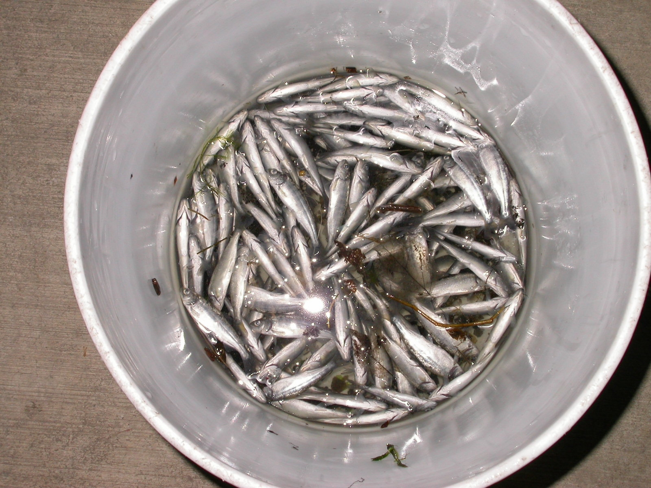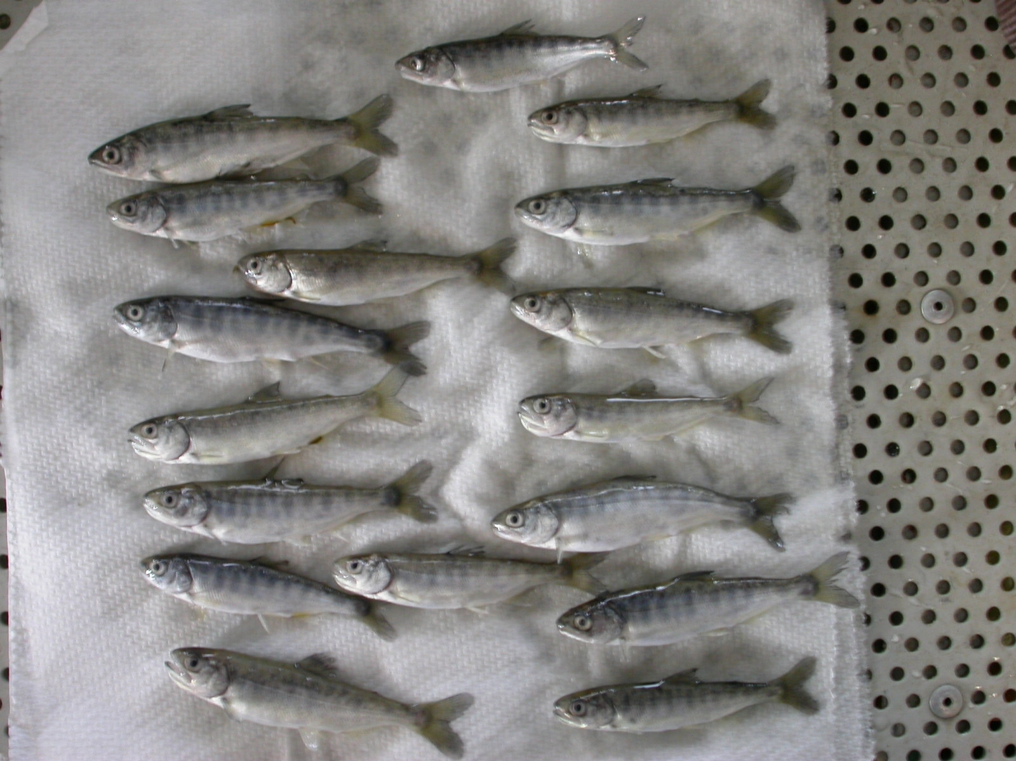

Ben and Tammy talked on Sunday on 15 April. There was some concern about the change in operations when the sample size was for two hours in the morning.

Some operational background information-
In 2006, PH2 had three modified units operating.
In 2007, PH2 has four modified units operating Units 15 and 17 are OOS due to headgate problems). TIES are not installed due to the TIE crane being out of service. Halogen lights were re-installed in the DSM after the first spike in mortality in March. The B2CC has been operating since early March. Spill started on 10 April.

Given the fact that elevated mortality and descaling occurred only in Spring Creek fish, Fisheries feels that the problem may not be in the bypass system. It is recognized that the U11 gatewell appears to be more turbulent under normal operating conditions. Also, since the mortality occurred with both types of orifice lights, the Project proposes returning to the LED lights. These lights last longer and do not produce as much heat, thus keeping the orifice lenses cleaner, longer.

Bonneville Project Fisheries

